Crime Reporting and Tracking
Guided By: Gayatri Dantal

Mr. Asim Shaikh Mr. Nitesh Mistry Mr. Imran Memon
BE-IT, BE-IT, BE-IT,
asim0492@gmail.com nitzmistry@gmail.com imrangmemon@gmail.com
Mumbai, India. Mumbai, India. Mumbai, India.

Abstract— Pre Crime aims at predicting crimes which are most probably to occur on the basis of the previous records and using complex data mining algorithms the date and time can also be predicted. FIR can be launched by a registered user any where and anytime this makes the Precrime robust as ongoing crimes can be reported.

Introduction

As ensuring public security is becoming important part of any government, Pre Crime is based on system that analyses criminal data based on previous records. Pre Crime is divided into two parts viz., Android app and Windows app. The present system which is based on manual work to register F.I.R is insufficient of predicting or forecasting the crimes. Pre crime is based on data mining which uses data stored in database and represents them in easy way to understand tabular and graphical form.
National surveys demonstrate that millions of crimes go unreported. Several reasons may contribute to this lack of reporting and we are investigating these potential reasons and how they may be addressed. We are developing an android application that provides an anonymous and secure mechanism for both victims and witnesses to report crimes to police.
The mission of PreCrime is simple: place officers at the right time and location to give them the best chance of preventing crime.
Our windows system is based on data mining that will use data stored in database to analyse the criminal data and to predict and forecast the upcoming crimes. Which will be highlighted in the Google Maps and represented in tabular and graphical form.
Our android application that provides an anonymous and secure mechanism for both victims and witnesses to report the ongoing crimes to police. The proposed system will automatically inform the on-duty police officers and provide searchable overviews for the public at large.
We believe police and people might find such as system a convenient alternative for forecasting and reporting crime.

Ease of Use

Precrime app can be used any android user on his android phone .Once getting registered the user can lodge a complaint in the nearest police station. The user can also inform his near one when he is in danger by just clicking on the help button on the homepage of the application.
The windows part will run on any windows platform windows XP to windows 8 with a minimum configuration of ram of 1GB and processor 2 GHZ which are available everywhere now a days, which will be easy to use by the police officials and the administrator.
The android application will be available for any android user and will run on any android enabled mobile device with a minimum android version of v.2.3 (Ginger Bread).

LITERATURE SURVEY

National surveys demonstrate that millions of crimes go unreported. Several reasons may contribute to this lack of reporting and we are investigating these potential reasons and how they may be addressed. We are developing an online system that provides an anonymous and secure mechanism for both victims and witnesses to report crimes to police. The system is implemented and tested in the US. Potential users were surveyed to determine their intent to use the system. Respondents found the online system useful, accessible, and safe to report crime, but the type of crime and the urgency of response is a determinant in the decision to use the system versus reporting it to a live person.

METHODOLOGY

Two applications has to be developed. Windows based application will be used by authorized police officer and Mobile application used by the citizens to report the ongoing crime and police officers to get notifications about crime.

Following are the functions of two applications:

  - WINDOWS APPLICATION
- Accept report from android application
- Verify the report is true or false alarm
- Inform nearby police officers
- Take past crime records
- Process the records
- Predict from records
- Highlight predicted data in the Google Maps
- Represented it in a tabular and graphical form

  - ANDROID APPLICATION
- Register user with Adhar card number
- Identify longitude and latitude of the user
- Generate report
- Send report to the police station server

DATA FLOW DIAGRAMS

Zero level DFD

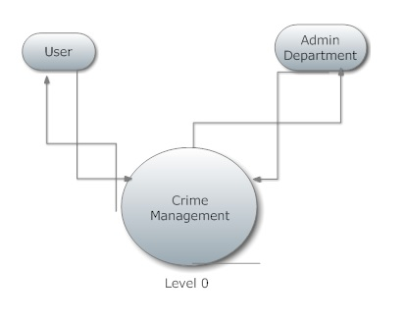

Level one DFD

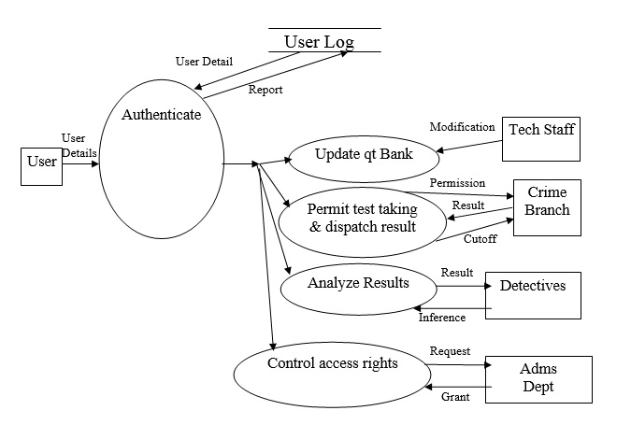

Level two DFD for authenticate

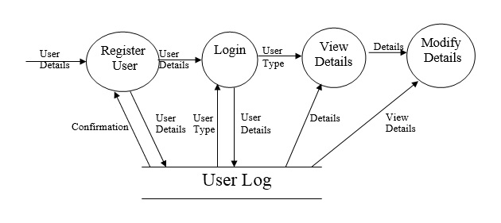

USE CASE DIAGRAM

Android Application
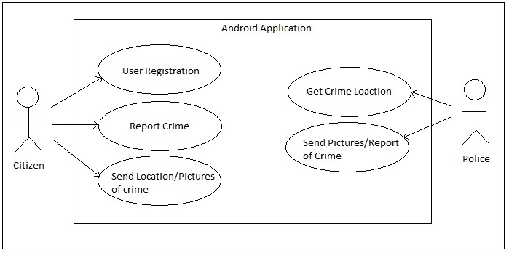

Windows Application

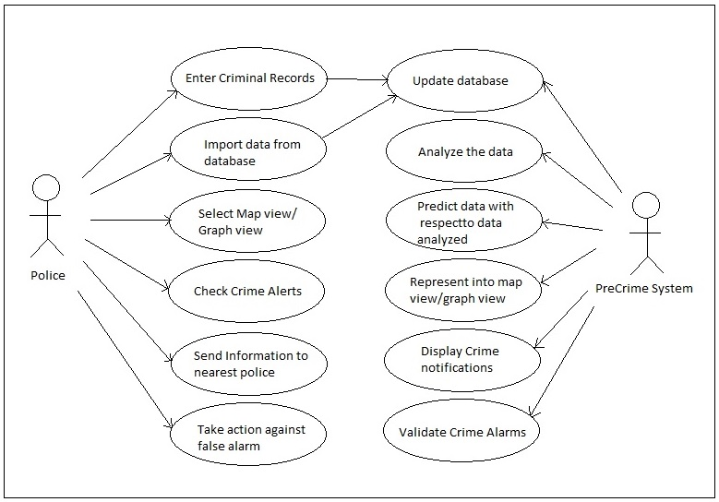

ER DIAGRAM

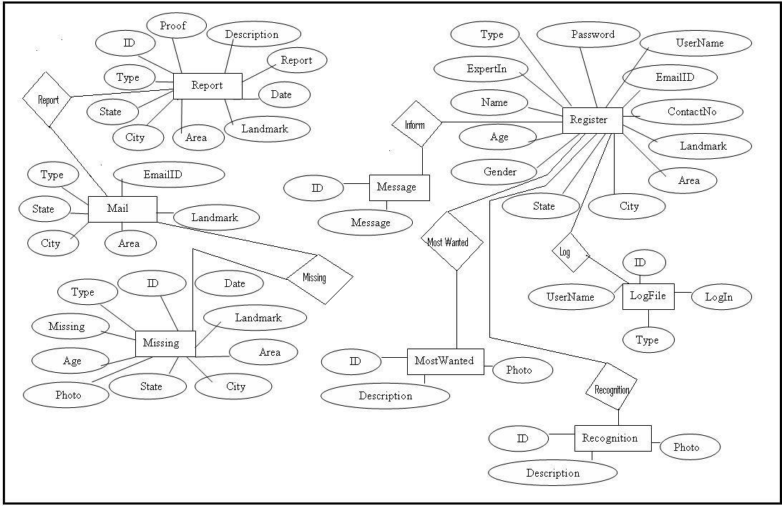

SCREEN SHOTS

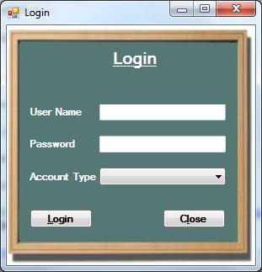

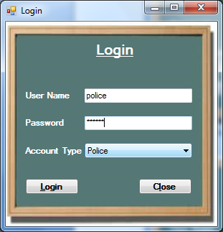

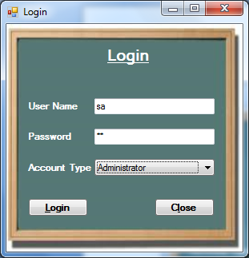.


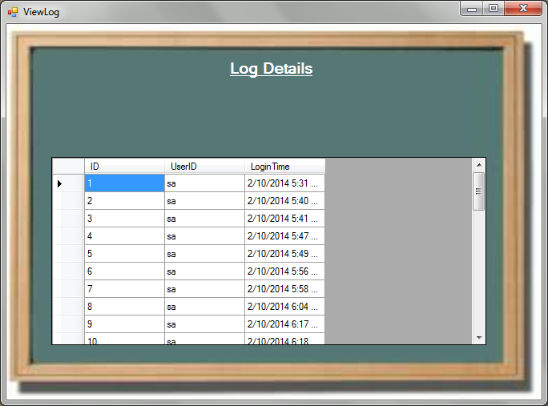

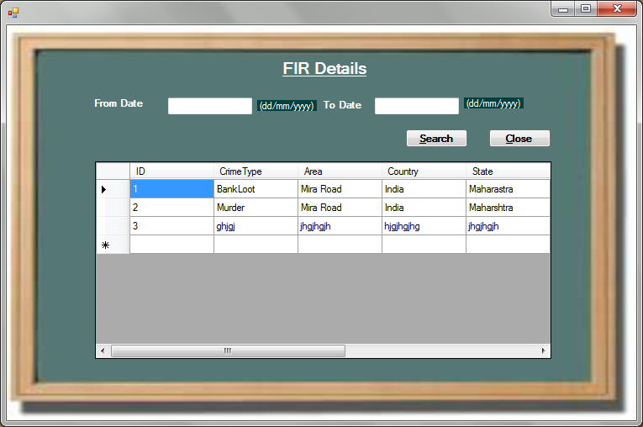

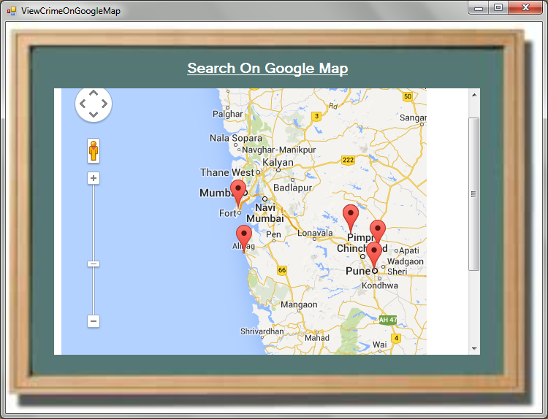

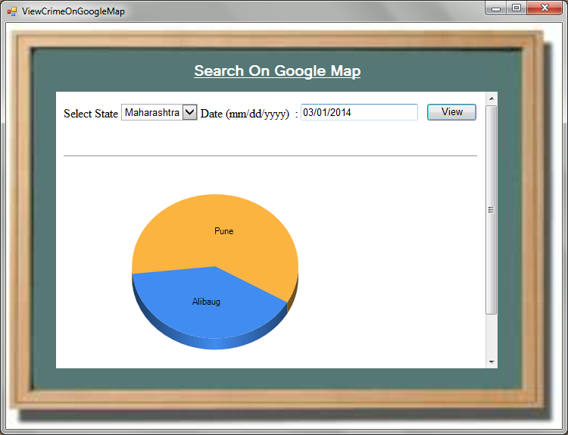

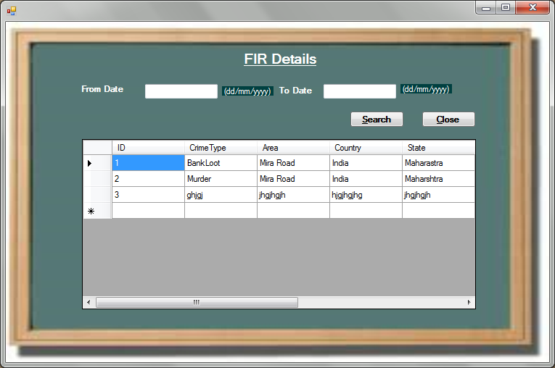

Copyright Forms
You must submit the IEEE Electronic Copyright Form (ECF) as described in your author-kit message. THIS FORM MUST BE SUBMITTED IN ORDER TO PUBLISH YOUR PAPER.

Acknowledgment
A few sublime human experiences defy expressions of any kind, and a feeling of true gratitude is one of them. I, therefore, find words quite inadequate to express my indebtedness to my Guide Prof. Gayatri Dantal for her virtuous guidance, encouragement and help throughout this work. Their deep insight into the problem and the ability to provide solutions has been immense value in improving the quality of project at all stages. This experience of working with them shall ever remain a source of inspiration and encouragement for me.
I express my thanks to Prof. Gayatri Dantal, HOD (IT), SLRTCE, Mira Road , for extending her support that she gave truly help the progression of the project work. I express my thanks to Prof. Anil Chaturvedi, Asst. Prof., SLRTCE, Mira Road for extending his support.
My sincere thanks to Dr. P. V. Pradhan, Director and Dr. S. Ram Reddy, Principal , SLRTCE , Mira Road for providing me the necessary administrative assistance in the completion of the work.
I am extremely grateful to the celebrated authors whose precious works have been consulted and referred in my project work. I also wish to convey my appreciation to my friends who provided encouragement and timely support in the hour of need.
Special thanks to my Parents whose love and affectionate blessings have been a constant source of inspiration in making this a reality.
All the thanks are, however, only fraction of what is due to Almighty for granting me an opportunity and the divine grace to successfully accomplish this assignment.

References
- http://www.nowtheendbegins.com/blog/?tag=rapid-information-overlay-technology
- http://www.marketoracle.co.uk/Article40937.html
- http://www.hendonpub.com/law_and_order/articles/2013/06/precrime_detecting
- http://edition.cnn.com/2012/07/09/tech/innovation/police-tech/index.html
- http://www.predpol.com/
- http://www.kurzweilai.net/minority-report-style-pre-crime-prediction-using-twitter-data-possible
- Brantingham, P., Brantingham, P., (1984) Patterns in crime. New York: Macmillan.
- Brown, D.E. (1998) The Regional Crime Analysis Program (RECAP): A Framework for Mining Data to Catch Criminals. in IEEE International Conference: Systems Man and Cybernetics Society.
- Mamalian, C.A. & LaVigne N.G. (1999) The Use of Computerised Crime Mapping by Law Enforcement: Survey Results. National Institute of Justice Research Preview.
- .

